Batch Processing

Comments

User Guide

The input file for Batch Comments is an Excel spreadsheet, saved as a .csv file. The input file contains a Header row and a Column Headings row. The input rows follow.

Header row – Data is as follows:
Column A – will always be the value “HD”
Column B – Institution Code (IUBLA, IUINA, etc).
Column C – User’s Department
Column D – User’s Name
Column E – User’s Email Address

Column Headings row – description of column headings are shown in the Input Row section, along with their corresponding column.

Input row – ALL ALPHA DATA INPUT MUST BE IN ALL CAPITAL LETTERS. There is 1 exception: the Comments field. This field may be in mixed-case. Required fields are in bold type. Use Screenshot 1 for visual reference.

Emplid (column A) – System ID number

Institution (column B) – campus identification, (IUBLA, IUINA, etc)

Admin Function (column C) – Administrative Functions; valid values are ADMA, ADMP, AWRD, EVNT, FINA, PROS, SFAC, STRM, GEN & SPRG.

Category (column D) – valid values depend on Function

Department ID (column E) – will default to blank if no input provided

Comment Emplid (column F) – emplid for person assigning the Communication; will default to CMNTPRCS if no input provided

Comment Date (column G) – Date that the Comment is being assigned; will default to system date if no input provided.

Comments (column H) – Text of the Comment; will default to blank if no input provided.

Variable Data (columns I – N) - This data will be the data specific to the Admin Function. The number of columns of variable data will depend on the value of the Admin Function. The variable data values for each Admin Function are as follows:

ADMA – ACAD CAREER, STDNT CAR NBR, ADM APPL NBR
ADMP – ACAD CAREER, STDNT CAR NBR, ADM APPL NBR, APPL PROG NBR
AWRD – AID YEAR, ACAD CAREER, ITEM TYPE
EVNT – CAMPUS EVENT NBR, EVENT MTG NBR
FINA – AID YEAR
GEN – No variable data for GEN
PROS – ACAD CAREER
SFAC – BUSINESS UNIT, ACCOUNT NBR, ACCOUNT TERM
SPRG – ACAD CAREER, STDNT CAR NBR
STRM – ACAD CAREER, STRM

Screenshot 1
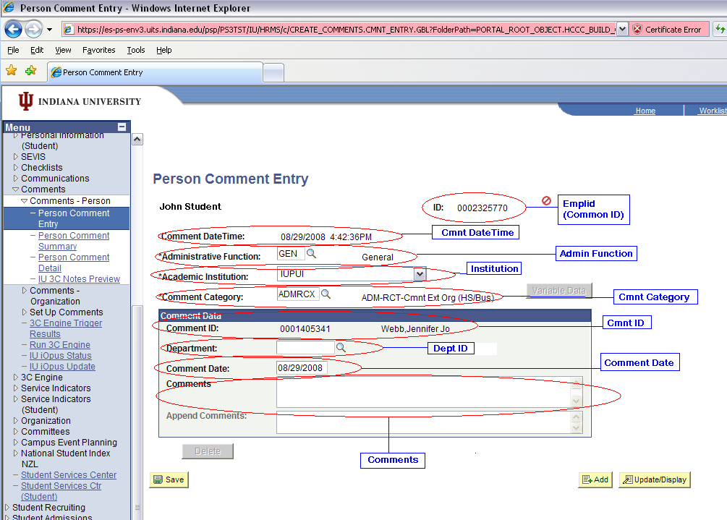

Example input file:
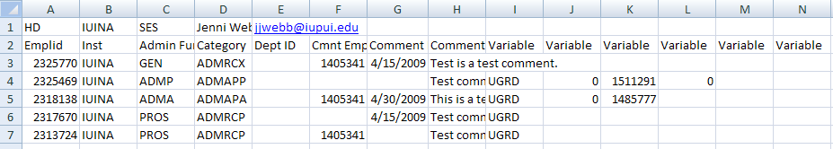

Save Files

User will save Excel file as a .csv file. Change ‘Save as type’ field to CSV (Comma delimited)(*.csv). Format for file name is iu3cload.cmnt.*.csv. The wildcard (*) can be any descriptive text. Please do NOT include any spaces or special characters (underscores and periods are allowed).

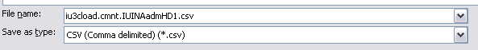

You will also need a .recon file containing the total number of rows of input in the .csv file (including the 2 header rows). If you have 5 rows of actual input (as in the example shown above), and you have 2 header rows, then your .recon file should contain a value of 7. Include a hard return after the data (press the Enter key once). If the user doesn’t create a .recon file, the processor will need to do this before submitting the files to DTP.

Using Notepad, create the file.

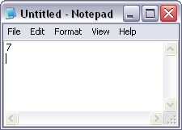

Change ‘Save as type’ to ‘All Files’. Save file as iu3cload.cmnt.*.recon. The wildcard portion of the file name must match the wildcard portion on the .csv file.

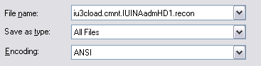

Drop Files to Folder

Drop .csv and .recon files into \\ADS\USSS\Campus_Community_Batch_Loads_RC\Batch_3Cs. Drop the files by 12 Noon to guarantee same-day processing. Any files dropped after 12 Noon may possibly not be processed until the following business day.

Questions
Send any questions to SES-BatchProcessing@exchange.iu.edu.

Mapping

You may need to map a new drive to \\ADS\USSS.

